**CRACK THE COVID-19 CRISIS**

**BY**

[**NASSCOM FUTURESKILLS AND IBM**](https://beatest.in/challenge/3)

**Team Name:** SWECHA

**Title of the project:**SAHAYYA

**SOLUTION ARCHITECTURE**

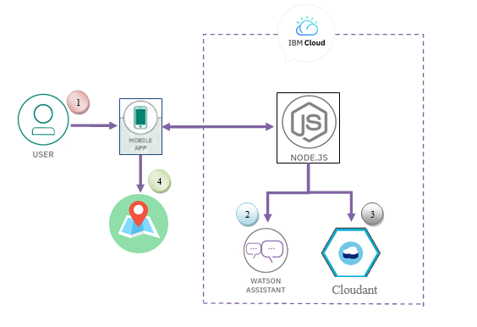

**Team Members:**

1. T. Srikanth
2. B. Laxmi
3. B. Santhi
4. B. Ranjith

**Team Mentor:** Dr.Ch.Santhan Kumar